**ЛИСТ СОГЛАСОВАНИЯ ВЫВОДОВ МИКРОКОНТРОЛЛЕРА**

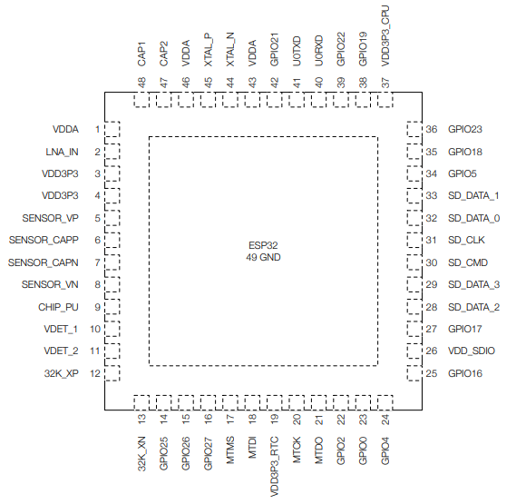

|  |  |  |  |
| --- | --- | --- | --- |
|  |  |  |  |
|  |  |  |  |
|  |  |  |  |
|  |  |  |  |
|  |  |  |  |
|  |  |  |  |
|  |  |  |  |
|  |  |  |  |
|  |  |  |  |
|  |  |  |  |
|  |  |  |  |
|  |  |  |  |
|  |  |  |  |
|  |  |  |  |
|  |  |  |  |
|  |  |  |  |
|  |  |  |  |
|  |  |  |  |
|  |  |  |  |
|  |  |  |  |
|  |  |  |  |

Проектирование электроники (ФИО, подпись, дата):__________________________________________________

Выводы согласованы с программистом (ФИО, подпись):_______________________________________________